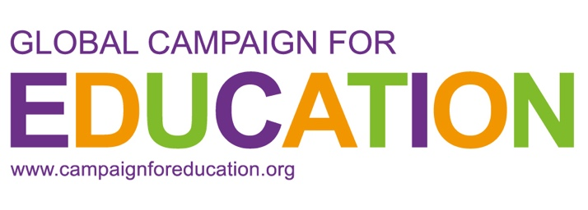

Name of Organisation/Coalition:
Is your organisation/Coalition formally registered as an NGO?
Is your organisation fiscally hosted by another organisation?
Year the organisation/coalition was registered:
Link to website/social media page:
Country:
Region:
Name of person completing survey:
Email address:

Section 1 (Previous mapping activities)
What is the percentage composition of youth and/or student members in your organisation/coalition’s decision-making bodies? Could you explain how these members are selected or elected?
How many youth and/or student led- organisations are members of your organisation/coalition? Kindly provide a list of them.
Has your organisation/coalition undertaken mapping of youth & student organising before? If yes, kindly share more the mapping report/findings if there is one?
How connected is your organisation/coalition to youth & student led organisations/initiatives/movements?
Are there currently functional and active youth networks, spaces and collaboration between youth & student organisations in your context?
Please elaborate how these connections between youth & student organisations/networks/coalitions function? If there are none then list the barriers or challenges in creating connected networks and collaborations?
Does your organisation/coalition have a dedicated young person to serve as a focal point who will be in charge of leading the mapping activities and being involved in peer to peer exchanges? How is this young person selected or elected?

Section 2: (Mapping Needs & Purpose)
What mapping needs does your organisation/coalition have in terms of mapping youth & student organising in your context?
How will this mapping be used in your organisation's mobilisation and youth engagement work when it comes to advocacy, lobbying, activism and research?
Would your organisation consider amending its structures to enable youth and student representation in its’ decision making bodies?
What collaboration would your organisation/coalition need from the GCE secretariat to undertake these mapping activities?
What resources/capacity/collaboration would your organisation/coalition need in order to undertake mapping activities?
How does your organisation/coalition see these mapping activities tangibly being translated into movement building and linkages across GCE movement?
Does your organisation/coalition see value in GCE creating spaces for peer to peer learning and exchanges regarding mapping and forming youth representative structures? If yes, please elaborate how?

